- This resource histogram provides a clear and concise view of resource utilization and availability. The horizontal axis represents the timeline in days, and the vertical axis depicts the quantity of resources. Each bar on the graph corresponds to the daily resource allocation, with each bar's color indicating the resource type.

Based on this information, we can deduce that the project spans 39 days to are allocate resources . These resources fall into three distinct categories, denoted by the colors yellow, grey, and blue. For instance, on day 1, it requires 3 yellow resources. By extending this analysis, we identify that days 13, 31, 32, and 33 are the most resource-intensive, each demanding a total of 9 resources. These days are the busiest in terms of resource allocation. Notably, day 13 requires three different resource types, whereas the other three days only involve two resource types. Conversely, days 10, 21, 26, and 27 are the least resource-intensive, each requiring just 1 resource. These days represent the least demanding periods for resource allocation.

  - Gantt Chart
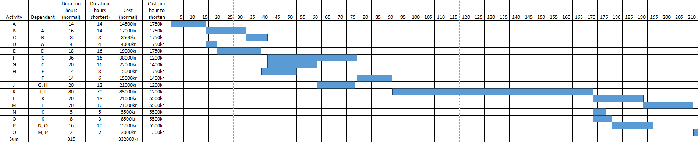
The Gantt Chart is depicted with cells representing a 5-hour time scale.

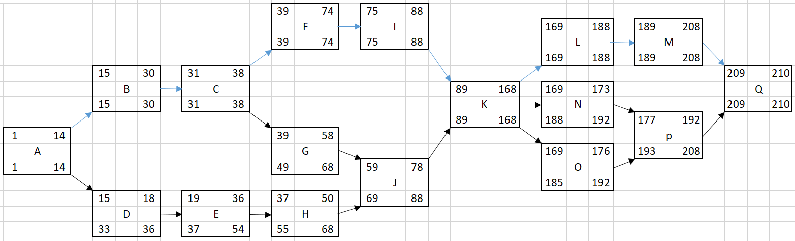
  - Network Diagram
The numbers above each activity show the early start and early finish. The numbers below show the late start and late finish.
The blue arrows show the Critical Line: A + B + C + F + I + K + L + M.
The approach involves working backward from the project's final activity. By doing so, we can observe that task Q cannot start until task M is completed. This backward analysis continues to task K, which, in turn, cannot initiate until task I is completed.

  - Lowest Cost to Shorten the Project by 30 Hours
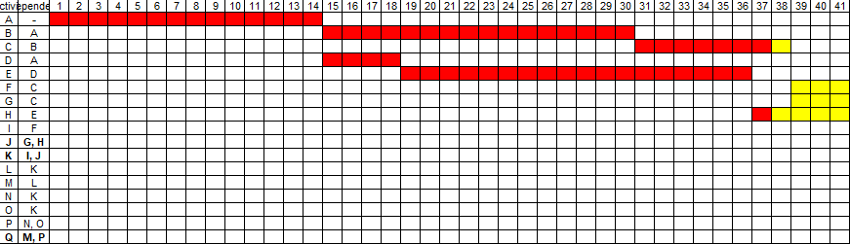
Step 1:
Given that 60 hours have already been spent on the project, our task is to pinpoint its progress at this stage. To achieve this, we can create a Gantt Chart using cells that represent a 1-hour time scale. Starting from day 1, we'll mark the cells horizontally, considering that some activities may be running in parallel.

At the 60-hour mark, we observe the following:
- Activity C has 1 hour remaining to completion.
- Activity H has just commenced and is in its initial hour.
- Activities A, B, D, and E are already completed, and we won't consider further shortening these as they have already concluded.

Step 2:
To identify the most cost-effective way to shorten the project by 30 hours, which means we need to reduce the project duration from 210 hours to 180 hours. We can begin by examining the "cost per hour to shorten the time" from the activity list. Upon reviewing the data, we find that activities F, J, K, and Q all have the lowest cost of 1,200 kr per hour to expedite. However, Q is not considered because it has no time to shorten.

To ensure the project concludes within 180 hours, we will utilize the created network diagram. The numbers displayed above each activity indicate the early start and early finish times, while the numbers below represent the new early start and early finish times following each selected activity's time reduction. The approach for selecting activities to shorten is based on three criteria: prioritizing activities with the lowest cost per hour, focusing on those that are closest to the final activity in the project sequence, and following the Finish-to-Start dependency. This method will help us efficiently reach the target project duration.

The first activity to shorten is activity K for 10 hours:
As activity K is one of the activities that has the lowest cost per hour to shorten the time, and among these is the closest activity to the final activity.
The new finish time for activity K is 158.
The new finish time for the project is 200.
The cost is 1200 x 10 = 12000 kr.

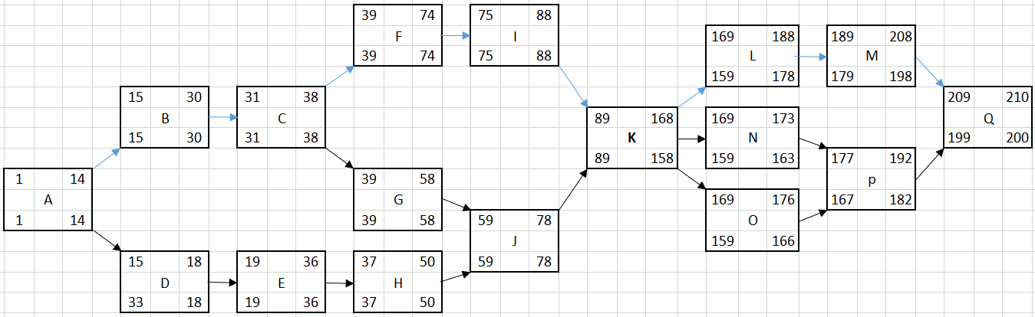

The next activity to shorten is activity I for 8 hours:
As activity K has a Finish-to-Start dependency to activity I.
The new finish time for activity I is 80.
The new finish time for activity K is 150.
The new finish time for the project is 192.
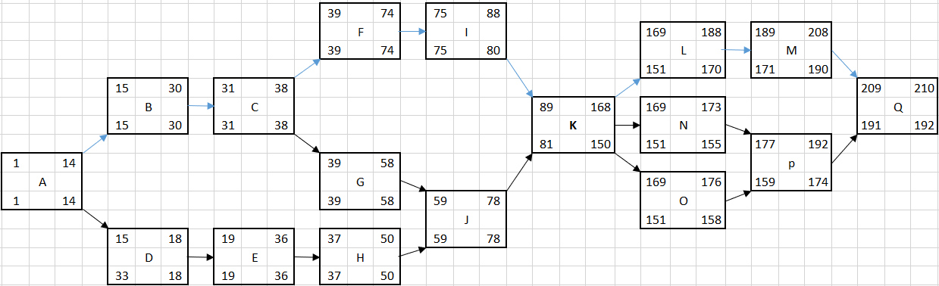
The cost is 1200 x 10 + 1400 x 8 = 12000 + 11200 = 23200kr.

The next activity to shorten is activity F for 2 hours:
As activity K still has a Finish-to-Start dependency to activity I.
The new Finish-to-Start dependency for activity K is activity J and activity I.
The new finish time for activity F is 72.
The new finish time for activity I is 78.
The new finish time for activity K is 148.
The new finish time for the project is 190.
The cost is 1200 x 10 + 1400 x 8 + 1200 x 2= 12000 + 11200 + 2400 = 25600kr.
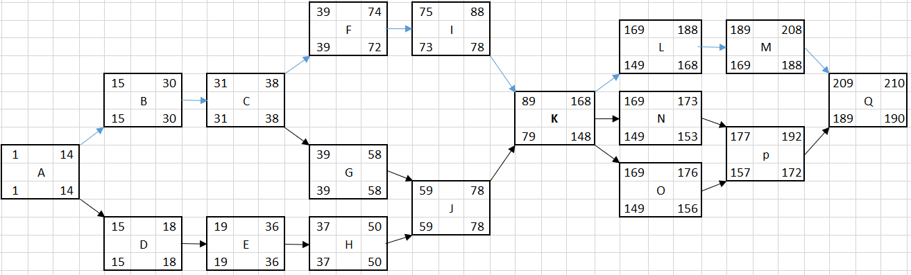

As the Finish-to-Start dependency for activity K is changing between activities I and J.
Set the finish time for the project to 180 and calculate backwards.
The new start time for activity K is 69.
The new finish time for activity I is 68.
The new finish time for activity J is 68.
- The next activity to shorten is activity J for 8 hours:
- The cost is 1200 x 10 + 1400 x 8 + 1200 x 2 + 1200 x 8 = 12000 + 11200 + 2400 + 9600 = 35200kr.
The new finish time for activity G is 56 and shortened by 2 hours.
The new finish time for activity F is 62 and shortened by another 10 hours.
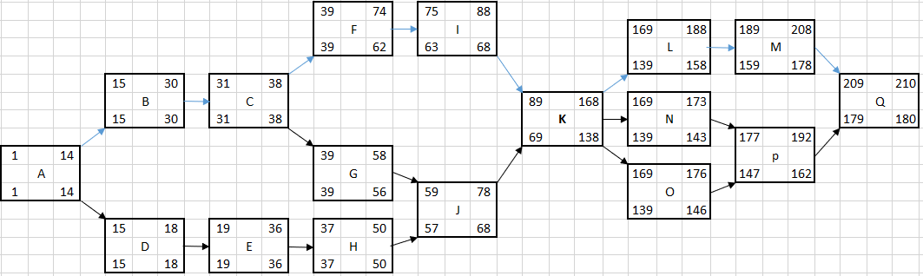
The cost is 1200 x 10 + 1400 x 8 + 1200 x 2 + 1200 x 8 + 1400 x 2 + 1200 x 10 = 12000 + 11200 + 2400 + 9600 + 2800 + 12000 = 50000 kr

We find the activities to shorten are activities G, F, I, J, K and the cost is 50000 kr.

